Cotton

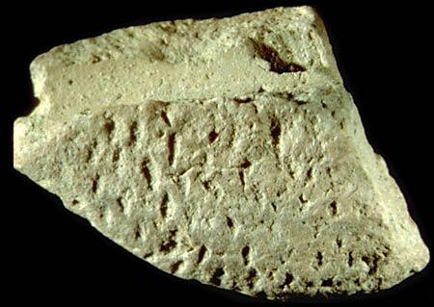
The earliest evidence for normal weave textiles at Harappa is found in this impression on a bead from Harappa, dating to around 3300 BCE. This fragment is only 1 cm long. Normal weave denotes interlacing single threads (one thread over/under the next). Such weaving may have been done on a simple loom with bone tools such as those seen in. Image: Harappa Archaeological Research Project; Harappa.com

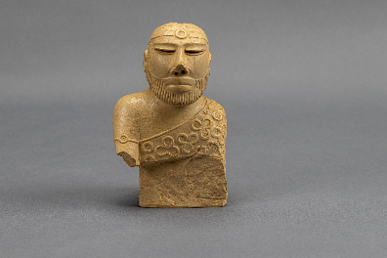

‘Priest king’ (replica): The textile over his shoulder suggests an advanced weaving industry in the Harappan civilization. Original: white, low fired steatite; Findspot: Mohenjo-daro, Pakistan; circa 2000¬1900 BCE; National Museum, Karachi, Pakistan (50.852).

